**St. Xavier’s College**

Affiliated to Tribhuvan University

Maitighar, Kathmandu



**A CASE-STUDY**

**ON**

**MONOPOLY MARKETING OF GATEWAYS**

**Under the supervision of:**

Er. Anil Kr. Sah

Sr. Lecturer

**Submitted by:**

Priya Sri(T.U.Exam Roll No. 10192/073)

**Submitted to:**

St. Xavier’s College

Department of Computer Science

Maitighar, Kathmandu, Nepal

Fall, 2019/20

**CERTIFICATE OF APPROVAL**

The undersigned certify that they have read and recommended to the Department of Computer Science for acceptance, a case-study entitled “ **MONOPOLY MARKETING OF GATEWAYS**” submitted by **Simran Panthi(T.U. Exam Roll No. 10205/073), Priya Sri(T.U.Exam Roll No. 10192/073), Vishal Thapa (T.U.Exam Roll No. 10214/073)and Suman Thapa (T.U.Exam Roll No. 10208/073)** for the partial fulfillment of the requirement for the degree of Bachelor of Science in Computer Science and Information Technology awarded by Tribhuvan University.

……………………………..

Er. Anil Kumar Sah

Supervisor / Sr. Lecturer

St. Xavier’s College

……………………………..

Mr. Jeetendra Manandar

Head of the Department

Department of Computer Science

St. Xavier’s College.

**Abstract**

Payment gateways holds a multibillion marketplace in today’s world. Such success truly reflects its necessity as well. It’s scope growth has always been proportional to digital literacy. With services and products being online, anytime, anywhere, gateways acts as a third-party for money transactions. Also comes alongside is gateways’ trickery.

This study involves how multinational gateways sometimes suppresses national and other local gateway just to rule the marketplace with its own policies. One reason could be the maintenance of monopoly in the market. Often times, some national gateways are seen to be using these multinational gateways for one reason or another. The question is, why can't a nation have its own national gateway. This concept when implemented not only put some effort towards national economy but also a talk of national pride. For example, in India Rupay (2012) was launched to break such monotonous practices and support national entrepreneurship and economy. Also discussed is how the seven-year-old card is giving the scare to global biggies such as Visa and MasterCard. And how all these actions are supporting ideas for individual nations towards having their own gateways. This study also gives a small brief on how a nation can implement its own gateway and what are the needed resources and infrastructure (Reference: E-commerce Project On ‘Dhanpatra’).

Note: This paper is not intended to demoralize any multinational gateway company. Their contribution can never be denied. It only focuses on how a nation’s own national gateway can be more beneficial in some terms.

**TABLE OF CONTENTS:**

CHAPTER 1

INTRODUCTION

CHAPTER 2

TRANSACTION COST

CHAPTER 3

THE MOST POPULAR GATEWAYS

CHAPTER 4

RUPAY

CHAPTER 5

MIR

CHAPTER 6

NATIONAL AND INTERNATIONAL GATEWAYS

CHAPTER 7

WHY NATIONAL GATEWAY

CHAPTER 0

LITERATURE REVIEW

RuPay, a new card payment scheme launched by the National Payments Corporation of India (NPCI), has been conceived to fulfill RBI’s vision to offer a domestic, open-loop, multilateral system which will allow all Indian banks and financial institutions in India to participate in electronic payments.

“RuPay”, the word itself has a sense of nationality in it. “RuPay” is the coinage of two terms Rupee and Payment. The RuPay Visual Identity is a modern and dynamic unit. The orange and green arrows indicate a nation on the move and a service that matches its pace. The color blue stands for the feeling of tranquility which is the people must get while owning a card of the brand ‘RuPay’. The bold and unique typeface grants solidity to the whole unit and symbolizes a stable entity.

Rupay Card is introduced to reduce the monopoly of foreign gateways like Visa and MasterCard because these are foreign companies or American companies and their commission is high i.e. the cost of transaction is high. Therefore, we can say that RuPay Card is an Indian payment gateway. It also works like Visa or Master Card and its commission is low. RuPay facilitates electronic payment at all Indian banks and financial institutions as well as it is being flourished in other countries like [Singapore, Bhutan, Maldives, etc.](https://en.wikipedia.org/wiki/Singapore)

CHAPTER 1

INTRODUCTION

## What is a Payment Gateway?

A payment gateway is a service that authorizes and processes debit/credit card or PayPal payments for online merchants and traditional brick and mortar businesses. A payment gateway facilitates these transactions by encrypting sensitive data and transferring it between a payment portal (a website or a mobile device) and the bank/front end processor.

It’s primarily uses includes:

* Withdrawing money from ATMs
* Payment at POS
* Transfer of money to different accounts
* Online payment and many more.

## How Does a Payment Gateway Work?

Ultimately, payment gateways facilitate communication between your website or brick and mortar store, the payment processor and the bank that issued the credit card being used to complete the purchase (or PayPal in case the PayPal payment method is used). Security is a major component of all payment gateways, therefore every transaction that occurs between the merchant and the issuing bank is encrypted to protect sensitive financial information.

Although the transaction process takes only a few seconds, several steps are accomplished during that brief window of time. Once the customer is prompted to a secure payment page and places an order, the transaction data (credit card number, CCV2 information, etc.) is encrypted and sent to your payment processor through the gateway. The payment processor communicates with the credit card’s issuing bank and retrieves feedback in a form of an approval or a declined message. The response is then transmitted to the payment gateway, which communicates it to your website. Finally, the information is interpreted and an appropriate response is generated. If the transaction was approved, the merchant fills the order.

A PG is a tunnel that connects your bank account to the platform where you need to transfer your money. A PG is a software that authorizes you to conduct an online transaction through different payment modes like net banking, credit card, debit card, UPI or the many online wallets that are available these days.

A PG plays the role of a third party that securely transfers your money from the bank account to the merchant’s payment portal.

To explain this in simpler terms, at the time of buying a book from a popular digital platform like Flipkart, when you make the payment for the book, a payment gateway helps you in the process by transferring your money to Flipkart.

A payment gateway focuses on securing the sensitive information given by the user throughout the process. It ensures security by encrypting data like card and bank details that have been provided by the user.

The following are the basic steps showing how a typical payment gateway works.

Step 1: A customer places his or her order and then presses the Submit or Checkout button, or its equivalent button, on the website

Step 2: Once this happens, the website or the e-commerce platform takes the customer to a payment gateway where he or she enters all the relevant information about the bank or the card they are using to pay. The PG then takes the user directly to the page of the issuing bank or a 3D secure page, asking for the transaction to be authorised.

Step 3: Once the payment gateway gets the approval for the transaction, the bank then checks whether the customer has sufficient balance in the account to make this transaction a success or not

Step 4: The payment gateway sends a message to the merchant accordingly. If the reply from the bank is a “No’”, then the merchant subsequently sends an error message to the customer, telling them about the issue with the card or the bank account. If the response is a “Yes” from the bank portal, then the merchant seeks the transaction from the bank

Step 5: The bank settles the money with the payment gateway, which in turn settles the money with the merchant

Once this process is completed, the customer gets a confirmation message of the order being placed.

As mentioned earlier, the transaction of money involves sensitive information about a person’s bank and card details that are entirely personal to him or her. Therefore, it is imperative to make sure that this information stays safe.

## How a payment gateway keeps information secure?

A payment gateway ensures the security of the information you put in. Here is a list of things that a PG does to keep your data safe:

* First things first, the entire transaction is carried out through an HTTPS web address. This is different from the HTTP as the S in the HTTPS stands for Secure. The transaction takes place through this same tunnel
* As a result of the hash function, the system often uses a signed request from the merchant to validate the request of the transaction. This signed request is a secret word, which only the merchant and the payment gateway know
* To secure the payment page result of the process, the IP of the requesting server is verified to detect any malicious activity
* Virtual Payer Authentication (VPA) is something that the acquirers, issuers and the payment gateways are backing to secure the process even more. VPA, implemented under the 3-D secure protocol, adds an additional layer of security and helps the online buyers and sellers to authenticate each other easily

## Benefits of using a payment gateway

Using a payment gateway is not just for transferring money, but it has other benefits as well. A PG can allow a merchant to give the user get a better experience.

* PCI-DSS Wallet – The [PCI-DSS compliance](https://razorpay.com/learn/payment-compliance-secure-payments/) makes it secure enough to allow the user to store their personal data in the portal or gateway for recurring payments. For example, if you are a frequent customer on Swiggy, then you can save your bank or card details on their site or app, and the gateway will keep it secure from any cybersecurity threat
* White-Label Wallet – Some payment gateways allow you to make digital transactions through mobile wallet apps. This is the current trend, as it enables the user to make all his transactions by just sitting at one place. You can bring in your money from the account balance to the mobile wallet app and then further use it to make payments on other apps or websites
* Fraud Screening Tools – Many payment gateways provide you with fraud screening tools to reduce the risk of losing information. These tools include the Card Code Value (CCV), Card Verification Value (CVV) or even the Address Verification Service (AVS). These tools ensure that there is no fraudulent transaction

A payment gateway focuses on creating a secure pathway between a customer and the merchant to facilitate payments securely. It involves the authentication of both parties from the banks involved.

The most significant advantage of a payment gateway is the fact that it allows millions of users to use it at the same time, making it possible for you to purchase or sell goods and services whenever you want.

CHAPTER 2

TRANSACTION COST

While making any transaction, it is supposed to cost some transaction commission. So, a very common question may arises as **“Where does that Transaction cost go?”**

In the case of withdrawing money from a different bank ATM, the transcation cost is beared by people themselves.

However, in the case of payment at POS and online payment, the transaction cost is beared by the merchant.

Now, that cost goes to the payment gateway company which is their service charge.

Annually, it all summed up to hundreds thousands of dollar which our country has to pay to these giants. This result is inflation and economic crisis if not well managed.

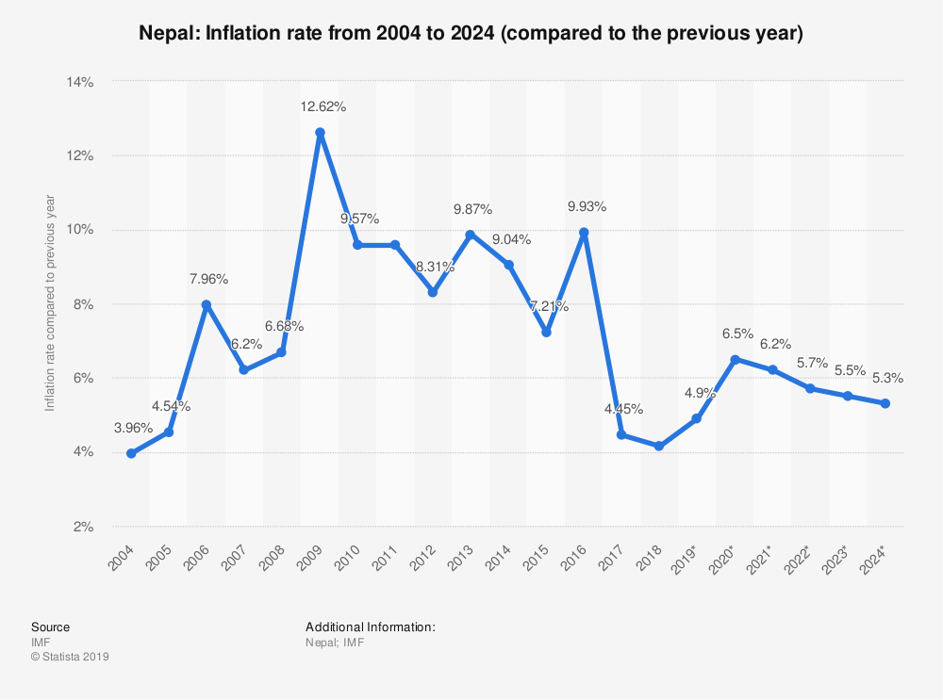

.

CHAPTER 3

THE MOST POPULAR GATEWAYS

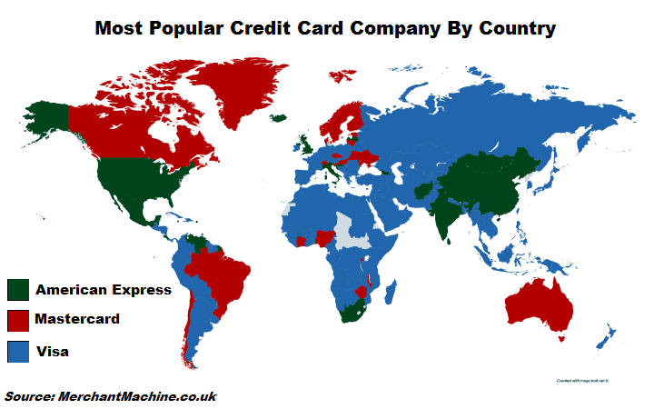

The map above shows which credit card company is the most popular in each country based on Google search data from [Google Trends](https://www.google.co.uk/trends/). It does not reflect the number of cards issued, nor transaction volume, simply the volume of searches for each company.

Overall, Google was able to provide data for 168 countries. Of those countries, **Visa** is the clear winner, being the most popular credit card company in **123 countries**. Surprisingly, **American Express (AMEX)** is the most popular in **23 countries** including the UK and US. Finally, **Mastercard** was the most popular company in **22 countries** including Canada and Australia.

However, when you look at data on the biggest credit card networks, the data looks slightly different. Visa is the largest creit card issuer in the United States. According to [CreditCards.com data](http://www.creditcards.com/credit-card-news/market-share-statistics.php#5-visa-2014), Visa has **304 million** cards in circulation in the US and **545 million** cards in circulation outside the US. Total transaction volume in the US was **$1.2 trillion** USD in 2014.

Mastercard has **191 million** cards in circulation in the US and **576 million** cards in circulation outside the US, which actually places it ahead of Visa globally (excluding US). However, US transaction volume is only **$607 billion**, around half of Visa’s total.

Finally, American Express is much smaller than the two giants with only **54.9 million** cards in circulation in the US and another **57.3 million** cards in the rest of the world. However, due to the affluence of their average customer, their transaction volume in the US is slightly higher than Mastercard’s at around **$668 billion**.

So why is Amex so popular in many countries, given it’s much smaller size?

This can likely attributed to the way Google collects search trends data. Data was for total searches for each company. And while Visa and Mastercard specialise in credit cards, American Express offers a variety of other services including insurance, travellers cheques and other travel and rewards services.

They also issue their own cards as opposed to Visa and Mastercard who issue their cards via banks, building societies, retailers and other financial services companies.

Also it should be noted that while we looked at China Unionpay, Discover Card and other credit card issuers, they were not included as there were no country where they were the most popular brand.

The reason why Unionpay was not the most popular brand in China is due to the fact data comes from Google, which only has around a 9% share of the [Chinese search market](https://www.chinainternetwatch.com/17415/search-engine-2012-2018e/) and likely skews towards expats and those with an international focus.

The full list of countries by credit card company popularity is below:

## The 123 countries where Visa is the most popular credit card company

1. Albania
2. Algeria
3. Andorra
4. Angola
5. Argentina
6. Armenia
7. Austria
8. Azerbaijan
9. Bahrain
10. Bangladesh
11. Barbados
12. Belarus
13. Belgium
14. Benin
15. Bhutan
16. Bolivia
17. Bosnia Herzegovina
18. Botswana
19. Brunei
20. Bulgaria
21. Burkina Faso
22. Burundi
23. Cambodia
24. Cameroon
25. Colombia
26. Congo (Democratic Republic)
27. Congo
28. Cuba
29. Cyprus
30. Djibouti
31. Dominican Republic
32. Ecuador
33. Egypt
34. El Salvador
35. Ethiopia
36. Fiji
37. **France**
38. Gabon
39. Gambia
40. **Germany**
41. Ghana
42. Greece
43. Guatemala
44. Guinea
45. Guyana
46. Haiti
47. Honduras
48. **Indonesia**
49. Iran
50. Iraq
51. **Ireland**
52. Israel
53. Jamaica
54. **Japan**
55. Jordan
56. Kazakhstan
57. Kenya
58. Kosovo
59. Kuwait
60. Kyrgyzstan
61. Laos
62. Lebanon
63. Liberia
64. Libya
65. Luxembourg
66. Macedonia
67. Madagascar
68. Malaysia
69. Mali
70. Malta
71. Mauritania
72. Mauritius
73. Montenegro
74. Morocco
75. Mozambique
76. Myanmar
77. Namibia
78. Nepal
79. **Netherlands**
80. **New Zealand**
81. Nicaragua
82. Niger
83. Oman
84. Pakistan
85. Palestinian territories
86. Panama
87. Papua New Guinea
88. Paraguay
89. Peru
90. Philippines
91. Poland
92. Portugal
93. Qatar
94. Romania
95. **Russia**
96. Saudi Arabia
97. Senegal
98. Serbia
99. Sierra Leone
100. Slovakia
101. Somalia
102. South Korea
103. **Spain**
104. Sudan
105. Suriname
106. Syria
107. Taiwan
108. Tajikistan
109. Tanzania
110. Thailand
111. Timor-Leste
112. Togo
113. Trinidad & Tobago
114. Tunisia
115. **Turkey**
116. Turkmenistan
117. Uganda
118. United Arab Emirates
119. Uruguay
120. Uzbekistan
121. Vietnam
122. Yemen
123. Zambia

## The 23 countries where American Express (AMEX) is the most popular credit card company

1. Afghanistan
2. Bahamas
3. Belize
4. Bermuda
5. **China**
6. Costa Rica
7. Croatia
8. French Guiana
9. Georgia
10. Hong Kong
11. Iceland
12. **India**
13. **Italy**
14. Latvia
15. **Mexico**
16. Mongolia
17. Puerto Rico
18. Singapore
19. South Africa
20. Sri Lanka
21. **United Kingdom**
22. **United States**
23. Venezuela

## The 22 countries where Mastercard is the most popular credit card company

1. **Australia**
2. **Brazil**
3. **Canada**
4. Chile
5. Côte d’Ivoire
6. Czech Republic
7. Denmark
8. Estonia
9. Finland
10. Greenland
11. Hungary
12. Lithuania
13. Malawi
14. Moldova
15. Nigeria
16. Norway
17. Rwanda
18. Slovenia
19. Sweden
20. Switzerland
21. Ukraine
22. Zimbabwe

CHAPTER 4

RUPAY

Rupay Card is an Indian domestic card conceived and launched by NPCI in 2012. It was introduced in the Indian payment system to reduce the monopoly of foreign gateways like Visa and MasterCard because these are foreign companies or American companies and their commission is high i.e. the cost of transaction is high. Therefore, we can say that RuPay Card is an Indian payment gateway. It also works like Visa or Master Card and its commission is low. RuPay facilitates electronic payment at all Indian banks and financial institutions.

Do you know that all major public sector banks, including SBI, have started issuing RuPay cards to all their customers? Also, it has come up with a high end technology chip named EMV (Europay, MasterCard and Visa) especially for high end transactions. A microprocessor circuit is also embedded in it with the information about the card holder.

**RuPay** is a [card scheme](https://en.wikipedia.org/wiki/Card_scheme), conceived and launched by the [National Payments Corporation of India](https://en.wikipedia.org/wiki/National_Payments_Corporation_of_India) (NPCI) on 26 March 2012.[[1]](https://en.wikipedia.org/wiki/RuPay#cite_note-1) It was created to fulfil the [Reserve Bank of India](https://en.wikipedia.org/wiki/Reserve_Bank_of_India)'s (RBI) vision to have a domestic, open and multilateral system of payments.

RuPay facilitates electronic payment at all Indian banks and financial institutions.[[2]](https://en.wikipedia.org/wiki/RuPay#cite_note-2) NPCI maintains ties with [Discover Financial](https://en.wikipedia.org/wiki/Discover_Financial), [JCB](https://en.wikipedia.org/wiki/JCB_Co.,_Ltd.) to enable RuPay card scheme to gain international acceptance.[[3]](https://en.wikipedia.org/wiki/RuPay#cite_note-3)[[4]](https://en.wikipedia.org/wiki/RuPay#cite_note-4)

In India, 90% of credit card transactions and almost all debit card transactions are domestic; however, the cost per transaction was low with RuPay compared to the foreign card schemes.

In November 2018, the then finance minister Mr. Arun Jaitley had said in a blog post “Today, Visa and MasterCard are losing market share in India to indigenously developed payment systems like UPI and RuPay Card whose market share have reached 65% of the payments done through debit and credit cards,”

Although the above is both UPI and RuPay Card combined, it is expected that RuPay cards contribute to ~50% of total debit cards by volume. The transaction share in volume and value terms is ~30% of the market share.

The key issue with RuPay cards has been that its growth in adoption primarily came when they were given to every account holder who opened a Jan Dhan account. The usage of RuPay card for daily transactions by the low income group holding Jan Dhan account will take time and has to be incentivised with discounts or cashbacks. Further, when the account holder travels abroad, there cannot be any usage of RuPay card and customers will have to fall back on Visa or MasterCard.

The major advantage of RuPay is the advantage to the banks involved. NPCI charges a flat Rs 0. 6 for acquiring and Rs 0.3 paise for issuing. For instance, if a customer with a RuPay card issued by Bank A pays through Bank B's PoS terminal, as the acquirer, Bank B will pay Rs 0.6 to NPCI and, as the issuer, Bank A will pay Rs 0.3. This is very very low when compared to Visa or MasterCard.[[2]](https://www.quora.com/Is-RuPay-giving-a-tough-time-to-Visa-and-MasterCard-in-India#cOlkt)

There is also a “nationalistic” sentiment that is being attached to RuPay cards - it is being designed in India and is seen as a competitor to MasterCard and Visa.

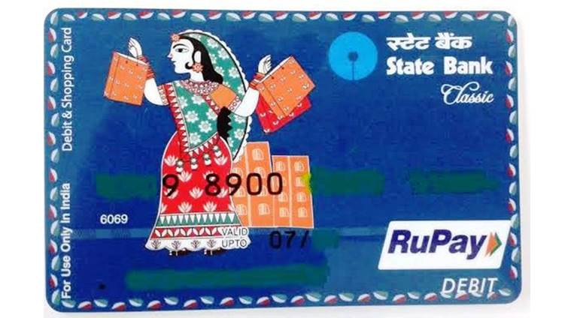

CASE I:

RUPAY: HOW A SIX-YEAR-OLD CARD GAVE THE SCARE TO GLOBAL BIGGIES SUCH AS VISA AND MASTERCARD

NEW DELHI: Mastercard recently complained to the Office of the United States Trade Representative that Indian government associated the use of RuPay cards with nationalism, claiming it serves as kind of national service. Mastercard complained that the Indian government had adopted a series of protectionist measures to the detriment of global companies.  
  
Why are global leaders with market dominance, technological superiority and decades of experience are scared of a six-year-old sarkari  project?  
  
Slowly and steadily, RuPay card has been expanding in the Indian market, riding on the back of the government. Thanks to PM Modi's policy of financial inclusion, RuPay has made quick inroads into the hinterland.  
  
At the Delhi Economics Conclave in 2015, Modi had spoken about emergence of RuPay cards as an alternative to the otherwise duopolistic industry dominated by Visa and Mastercard. “Thanks to RuPay cards, we introduced healthy competition in the debit and and credit card space traditionally dominated by a few international players,” he had said. India’s total debit-card volume is 925 million, according to Reserve Bank of India (RBI) data. RuPay claims to power over 500 million cards issued by nearly 1,100 banks — giving it more than 50% share in the country’s debit-card market by volume, beating the much older duo of Visa and Mastercard. In 2013, RuPay's market share was just 0.6 per cent.  
  
In 2009, the RBI had asked the Indian Banks Association to launch a not-for-profit company and design a rival card, then tentatively called India Card, that met the requirements of the domestic banks. The card was launched in 2012. A big boost for RuPay came when the government prescribed the issuance of RuPay cards to every account holder who opened the account under the Prime Minister Jan Dhan Yojana launched in 2014.

RuPay card usage at point-of-sales devices has jumped 135% to 459 million transactions in financial year 2017-18 as against 195 million last year. The number of RuPay cards in circulation also grew, having reached 494 million in financial year 2018 up 35% against 365 million in the previous year. RuPay card usage at ecommerce websites jumped 137% to reach 208 million transactions in financial year 2018 against just 87.5 million in 2017. In terms of value of payments, the transactions stood at at Rs 16,600 crore against Rs 5,934 crore the year before, a jump of 180%.

“We (RuPay cards) are already the No. 1 scheme in the number of cards issued. This year, we will become No. 2 scheme on value and volume done on PoS machines and ecommerce. So we will not be number 3 anymore behind Visa and Mastercard. We will pip one of them to become number 2. I don’t see a reason why we should not be Number 1 in couple of years, in both value and volume," Dilip Asbe, chief executive at National Payments Corporation of India (NPCI), which runs RuPay, said in April.  
  
PM Modi's drive for a less-cash economy in the wake of demonetisation has promoted RuPay card in the interiors of the country where paying with a card was a big novelty just five years ago. Finance Minister Arun Jaitley said recently that RuPay's total transactions had increased to Rs. 8,430 crore ($1.16 billion) as of September 2018 from Rs. 1,100 crore before demonetisation.  
  
Consistent government efforts through banks and special offers will further expand the reach of RuPay. For example, in August the GST Council allowed incentivising digital payments through Rupay card by way of cashbacks. Customers making payments using Rupay card or BHIM UPI will get a cashback of 20 per cent of the total GST amount, subject to a maximum of Rs 100.  
However, the biggest weapon that helped RuPay conquer a big chunk of the market was its flat fee. According to an ET Prime report that cited sources in the banking industry, for every RuPay-based transaction, NPCI charges a flat 60 paise for acquiring and 30 paise for issuing. For instance, if a customer with a RuPay card issued by Bank A pays through Bank B's PoS terminal, as the acquirer, Bank B will pay 60 paise to NPCI and, as the issuer, Bank A will pay 30 paise. This is a tiny fraction of Visa and Mastercard’s merchant-discount rate, which is calculated as a percentage of the actual transaction amount.

The challenge RuPay faces is its limited reach in the premium segment. Its user base is still dominated by rural users. Nearly half of the RuPay cards have been issued to Jan Dhan account holders. So half of the RuPay users would be in low-income people who have recently been included in the formal banking system. Another challenge is the international acceptance. While the government is trying to turn RuPay into an international card, yet it may take a long time to match the acceptance level of Mastercard and Visa.

# CASE II:

# RUPAY GIVES GLOBAL CARDS A RUN FOR MONEY

### Today, there are over 1,100 banks issuing around 600 million RuPay cards.

India’s own RuPay card is gradually going global and giving tough competition to international players like Master Card and Visa. RuPay is India’s domestic payment card conceived and launched by the National Payments Corporation of India (NPCI) seven years ago.

RuPay currently has 33% market share of card transactions. Today, there are over 1,100 banks issuing around 600 million RuPay cards, half of which are in the mid and premium segments. It has collaborated with more than 600 international, regional and local banks across the country. Apart from India, it has been launched in foreign countries like Singapore, Bhutan, Bahrain, UAE and is going to be launched in Saudi Arabia next week during the visit of Prime Minister Narendra Modi.

According to figures of the Reserve Bank of India (RBI), RuPay reported 1 billion transactions through both online and offline merchant payment modes during 2018-19, about 70% jump compared to the 667 million transactions during 2017-18. Interestingly, RuPay transactions had risen 135% in the fiscal year 2018, compared to the previous year.

In contrast, debit cards overall were swiped 4.4 billion times for merchant payments in the financial year 2019, a jump of 32% from 3.3 billion transactions in the financial year 2018. It grew about 40% in financial year 2018, compared to financial year 2017.

RuPay is India’s first-of-its-kind domestic debit and credit card payment network, with wide acceptance at ATMs, POS devices and e-commerce websites across India. It is a highly secure network that protects against cyber hacks and is India’s version of the Master Card and Visa. It has been developed to offer secure, user friendly and cost-effective solutions to facilitate low value payments and build a cashless transaction environment.

According to a senior official of a private bank, RuPay is being increasingly preferred, although on a low base, and this could be because more people are using cards for payment in smaller cities and towns. He said that though the government has not mandated that only these cards should be issued, a large number of public sector banks are issuing RuPay cards.

India will launch RuPay card in Saudi Arabia during Prime Minister Modi’s visit to the country to help the Indian pilgrims visiting Mecca and Madina. With this, Saudi Arabia would become the third country in the Gulf region to get the RuPay card facility after the UAE and Bahrain. The Prime Minister is slated to visit Saudi Arabia on 29 October, where he will hold a bilateral meeting with Saudi Arabia King Salman Bin Abdulaziz Al Saud in Riyadh.

As a result of the growth of RuPay cards, American payment card firms Master Card and Visa have been losing market share since the November 2016 demonetisation drive, which was aimed at promoting digital payments. According to a media report, Master Card wrote to the US government in June last year, complaining against the Indian government using nationalism to promote the use of domestic payments network RuPay, and noted that New Delhi’s protectionist policies were hurting foreign payment companies.

RuPay has also tied-up with international players like Discover, Japan Credit Bureau and China Union Pay to enhance its international acceptance and recently achieved a milestone of issuing 25 million RuPay-Discover global cards. NPCI issues RuPay Global cards that run on the Discover Network when used outside India.

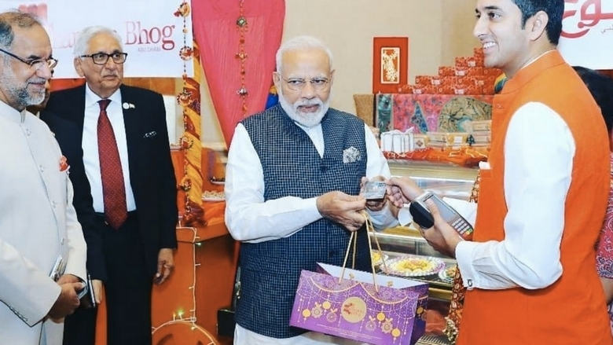

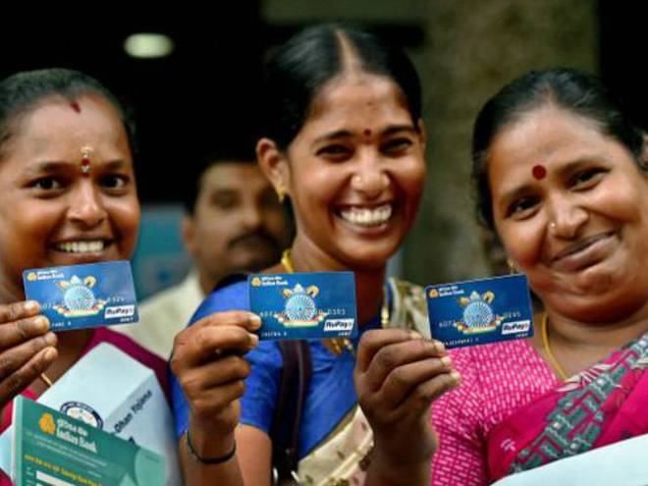

CHAPTER 4

MIR

Russia has been discussing the creation of a national payment system since the 1990s, however it was the US-sanctions against a number of Russian financial institutions in March 2014, which led to Visa and MasterCard stopping services to these institutions, that drove the Russian Government to sign into law a bill for the establishment of a national payment card system in May 2014. Both events were widely reported in the press, and two years on the National System of Payment Cards (NSPC) has been piloted with many of the country’s financial institutions moving over to the new system. What has it taken to get here and what does this mean for the global payments industry?

**BACKGROUND**

Following the problems with Visa and MasterCard in 2014, consumer confidence in the FIs involved took a dramatic drop leading to the decision by the Russian Government to go ahead with the implementation of the NSPC to limit its exposure to political risks in the future. With more than 90 per cent of all cards in the country branded either Visa or MasterCard, if something like this were to happen again, the effects could be disastrous. To counteract this, the Russian Government wanted to create a payment system where all domestic card transactions are processed internally, but cards are also accepted internationally.

Many financial experts argued that instead of creating a system from scratch, a system already in place should be used or a version of another payment system, such as unionpay international, should be adapted. However in july 2014, russia’s central bank decided to create a brand new system to ensure complete control over the process of building it, as well as not to offend smaller financial institutions in the country who felt that utilising one of the big fi’s existing processing and clearing systems would have further strengthened their position in the market.

Throughout the months that followed, processing and co-branding agreements with a number of international payments systems were signed, including JCB-NSPC cards, as well as processing agreements with MasterCard and Visa. The test system went into operation in December 2014, with eight FIs in the pilot. The institutions involved in the pilot, some of which were affected by US sanctions, were chosen to ensure that all logistical differences such as institution size, transaction volumes and the technological platforms in use were tested This enabled the NSPC to iron out any problems before its official launch.

MasterCard completed the certification of all Russian FIs issuing cards with the system and fully transferred the processing of all domestic card transactions through the NSPC on 31 March 2015, in time for the 1 April deadline. Visa took slightly longer, transferring the processing of its cards via the NSPC in May.

**CARD ISSUANCE AND ACCEPTANCE**

With the majority of cards in the country branded either Visa or MasterCard, the launch of a domestic card was important to the Russian Government and its Central Bank. The prototype of the NSPC’s card – branded Mir, which means ‘peace’ or ‘world’ in Russian – was introduced in June 2015 and officially launched in December  with seven financial institutions on board, and a further 35 agreeing to participate in issuing the card in 2016. Under Russia’s Federal Law, FIs deemed to be critically important by the Central Bank or those that offer merchant acquiring services must accept Mir transactions in order to help to drive mass adoption of the card. The aim is for 50-60 per cent of domestic cards to be Mir-branded cards by 2018.

It is clear that the NSPC has worked hard to get contracts in place to ensure adoption and acceptance of Mir card transactions both inside and outside of Russia. International payment system, JCB has agreed to issue three million co-branded Mir cards with Russian banks by the end of 2016, whilst other IPSs have also signed up to issue co-branded cards. BanknetVN signed a reciprocal agreement with the NSPC at the end of 2015 that will enable Mir cardholders to use their cards in Vietnam, and BanknetVN cardholders could use theirs in Russia, from 2016. The NSPC has a similar agreement with Turkey. These co-branding projects will mean domestic cardholder transactions will be processed via the NSPC, whilst transactions made outside of the country are processed via the agreed IPS.

For Russian FIs, the NSPC offers the reassurance of uninterrupted domestic transaction processing as well as reduced maintenance costs and interchange fees, but what does it mean for the rest of the global payments market?

**THE FUTURE**

The emergence of the NSPC and subsequent launch of the Mir card may not have had a significant impact on the rest of the world yet, but it is unlikely to stay that way. The introduction of the new payment system is expected to filter into neighbouring countries and beyond, something that has already been demonstrated by the agreement with BanknetVN and agreement in Turkey. Whilst co-branding projects enabling cardholders to use their cards internationally are a huge benefit for the Russian population, this could potentially lead to Mir acceptance (without the involvement of international payment systems) in the future.

In  just  two years since the law was passed by the Russian Government to create a national payments system: the system has been built from scratch and gone live (with the certification and migration of FIs with MasterCard and Visa cards to process transactions via the system), a new co-branded domestic card has been launched and is being issued by FIs, and numerous agreements with international and national payment systems have been signed to ensure the adoption and acceptance of the card domestically and internationally. This is certainly a case study that other countries considering creating their own payment systems can learn from, and a showcase of pairing domestic payment systems with international payment systems to increase the card acceptance network. With the issuance of contactless cards, host card emulation and secure remote payments planned for the future, one thing is evident – the NSPC is serious about competing with international payment systems and does not plan to remain a ‘national’ payment system for long.

## MIR CARD ACCEPTANCE IN OTHER COUNTRIES

* Vietnam
* Thiland
* United Kingdom





CHAPTER 6

NATIONAL VS INTERNATIONAL GATEWAY

RuPay is good alternative payment network option for Indian issuing banks. It charges them only INR 0.9 per transaction while VISA/MC fees can be as high as INR 3.

RuPay also doesn't charge anth for subscribing a bank to the network plus no monthly fees. E.g. VISA/MC subscription fees can be as high as USD 30-40K per bank with monthly fees fluctuating in a the USD 5-15K.

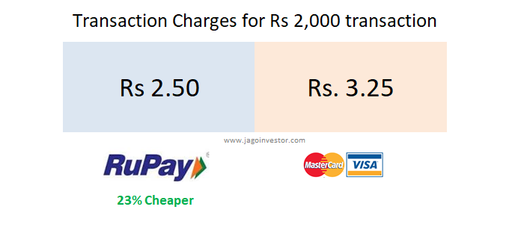

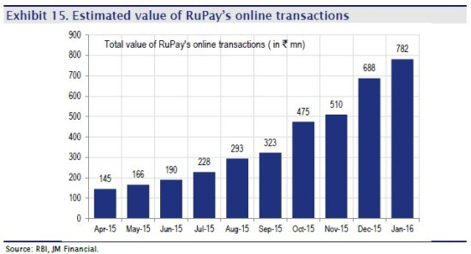

VISA VS MASTERCARD

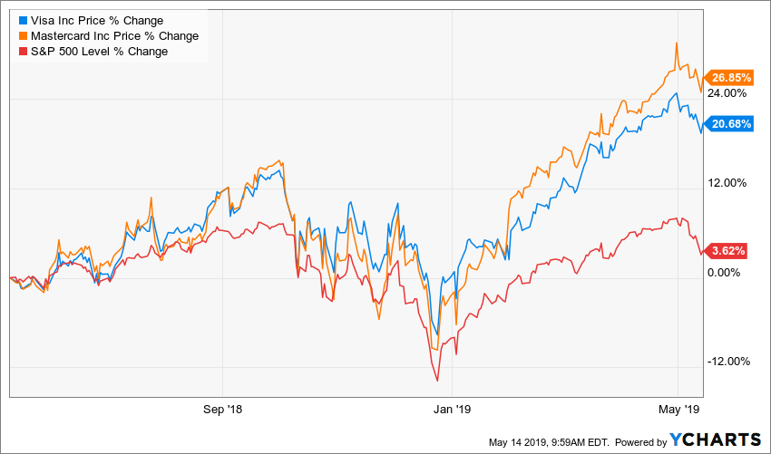

CHAPTER 7

WHY NATIONAL GATEWAYS

The main objective can be summarized as:

* Lower Transaction Cost
* National Economy Contribution
* Employment

CASE III:

4 years ago, when RuPay was just launched, NPCI head Sri A. P. Hota was invited to address the probationers of State Bank of India. I was one among the lucky few attended that lecture in Hyderabad. He spoke around 1 hour on RuPay card. It was a dream project then. Though I can't recall all the points, I will try to nerrate some important ones.

1. Master and Visa servers are in USA. The every transaction details goes through these servers. It means when we do transactions using Master or Visa, the details leaves the country. In case of RuPay card, the data is not shared to any other countries. This may not be an important aspect, but sounds good and makes us proud of RuPay.
2. Card Issuance Cost is lesser in case of RuPay compared to Visa or MasterCard. The bank has to pay some amount to card companies whenever they issue new cards and also annual fees. Indegeneous card costs less.
3. Be it RuPay or Visa or Master, they generate income whenever we do transactions. As the RuPay is a card brand of Not for Profit- section 25 company, transaction fee is lesser than Visa or Master which are of profit motive.
4. RuPay is accepted wordwide and is just like any other international brand. It has collaboration with Discover cards to use their platform when used outside India. Discover is popular than Visa and Master in US.
5. RuPay cards are PIN based rather than signature based. Thus RuPay is more secured. (Now all cards need PIN authentication in India)
6. NPCI is backed by 11 leading banks including SBI, BOB, PNB, ICICI, HDFC etc. It makes them to treat RuPay card as their own brand. If they don't do that, department of financial services will take further steps to make sure RuPay in India is like UnionPay in China. Government of India considers RuPay as a flagship project under DFS.

RuPay has already captured 36% of market share. 20% of the card transactions are happening through RuPay. It is a remarkable growth in less than 4 years. As it is being accepted on all POS, E-commerce sites, and even in Airport Lounges; the difference between the new desi card brand and eatablished players is getting narrowed. When such differences are not there, then we should support our own products and brands.

Likely the most obvious reasons:

1. Lower commission fee for merchants, making it more attractive
2. Lower / elimination of extra fees (e.g. banks paying joining and/or recurring fees to Visa/MasterCard)
3. Backing from the Indian government, as mentioned by [Krishnadas Mohandas](https://www.quora.com/profile/Krishnadas-Mohandas)
4. I would also venture a guess at potentially faster settlement/ transactions
5. There are also scheme-specific benefits. For example, *RuPay Kisan Card*is meant to address the credit needs of farmers in a sustainable manner.

REQUIREMENTS FOR A NATIONAL GATEWAY:

* Infrastructure
* Manpower
* Connection with banks
* Government Support Policies
* Collaboration



CASE IV:

## NRB PREPARING TO INTRODUCE NATIONAL PAYMENT GATEWAY

KATHMANDU, Jan 5: Nepal Rastra Bank is preparing to introduce a national payment gateway in a bid to conduct a regular monitoring of the digital payment system.

Talking to Rastriya Samachar Samiti, deputy governor of the central bank Chinta Mani Shiwakoti informed that the service that helps in the real-time gross settlement would come into effect within the next 18 months.

“All payment systems will be monitored, and all payments of VAT, income tax and excise duty can be made digitally, once the service comes into operation,” he said.

Likewise, the central bank is also preparing to make new laws to facilitate the digital payment, he informed. “The bank is preparing the draft of the act related to the issue.”

REFERENCES

* Rupay.co.in. (2019). *RuPay – A New Domestic Card Payment Scheme*. [online] Available at: https://www.rupay.co.in/ [Accessed 15 Aug. 2019].
* The Times of India. (2019). *News, Breaking News, National news, Latest Bollywood News, Sports News, Business News & Political News | Times of India*. [online] Available at: https://timesofindia.indiatimes.com/ [Accessed 15 Aug. 2019].
* <https://www.sundayguardianlive.com/business>
* [https://myrepublica.nagariknetwork.com](https://myrepublica.nagariknetwork.com/)